SOCIAL WELFARE DEPARTMENT

SWD ELDERLY INFORMATION WEBSITE
USER GUIDE FOR MANAGING USER ACCOUNTS FOR RECOGNISED SERVICE PROVIDERS OF THE PILOT SCHEME ON COMMUNITY CARE SERVICE VOUCHER FOR THE ELDERLY

VERSION 0.1

OCTOBER 2016

The Government of the Hong Kong Special Administrative Region
The contents of this document remain the property of and may not be reproduced in whole or in part without the express permission of the Government of HKSAR

TABLE OF CONTENTS

- OBJECTIVES 3
- PROCEDURES OF UPDATING VACANCY POSITION(S) 4
- PROCEDURES OF RESETTING PASSWORD 12
- CONTACT INFORMATION 14

- OBJECTIVES

Recognised Service Providers (RSPs) of the Pilot Scheme on Community Care Service Voucher for the Elderly (Second Phase) are invited to update vacancy position(s) of day care places and/or home care places in the web content management system of the SWD Elderly Information Website to enhance information transparency and promote informed choice of elderly persons and/or their carers in selecting RSPs that meet their individual needs.

This user guide targets at guiding CCSV RSPs to manage their user accounts in terms of
updating vacancy position(s) for day care places and/or home care places and
resetting their password and/or email address affiliated to their user accounts.

2. PROCEDURES OF UPDATING VACANCY POSITION(S)

Step 1: Login the web content management system in SWD Elderly Information Website
Login path: https://elderlyinfo.swd.gov.hk/cmsuser

Step 2: Enter the Username and Password distributed to you in a separate email; and wordings and/or numeric displayed in the CAPTCHA(驗證碼).

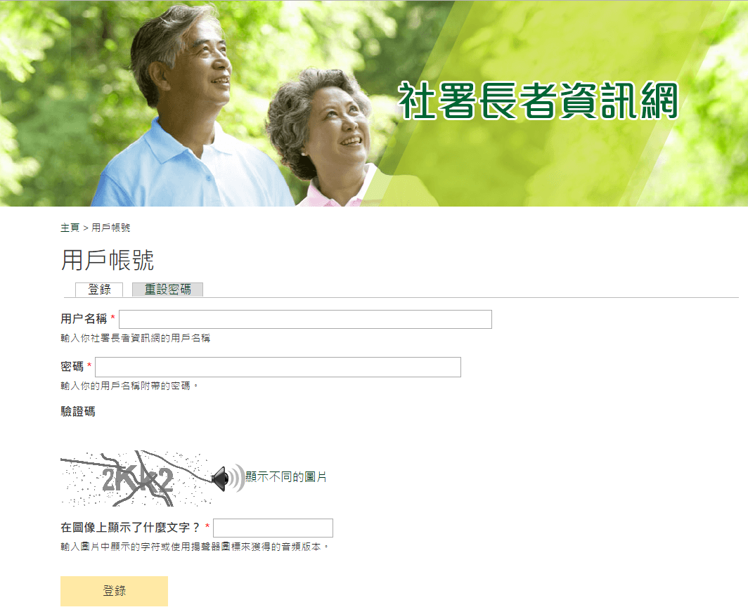

For successful login, users would be able to access the front page of the web content management system.
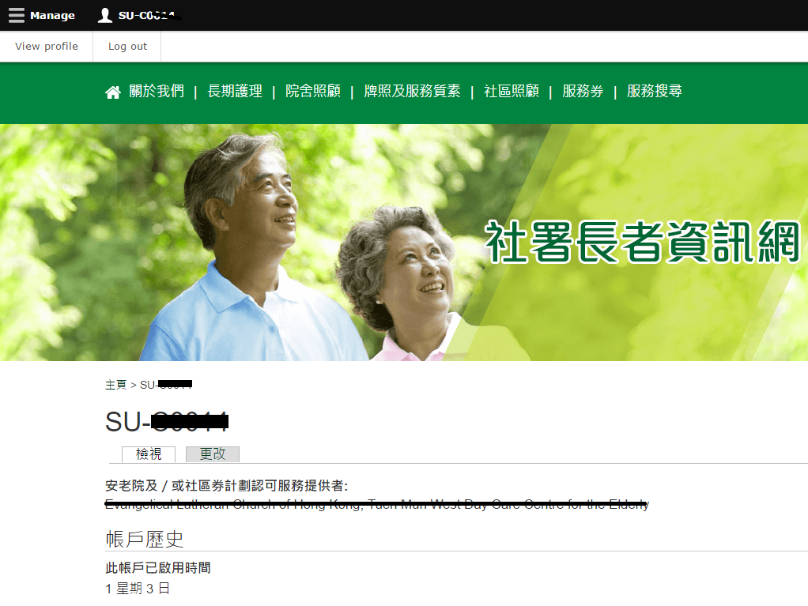

For unsuccessful login, users would be required to re-enter the username and/or password and/or CAPTCHA in the login page in accordance with the system alert messages displayed.

Step 3: Click “Manage” on the top-left corner after successful login.

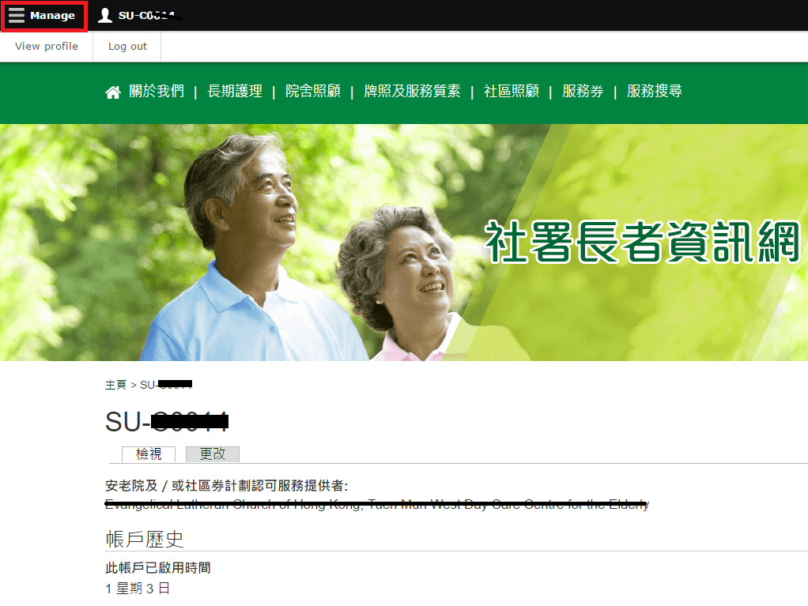

Step 4: Click “Edit Vacancy Record” under “Manage”.

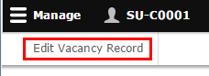

Step 5: Click “Edit Vacancy of (Code of CCSV Recognised Service Provider) (Name of CCSV Recognised Service Provider).

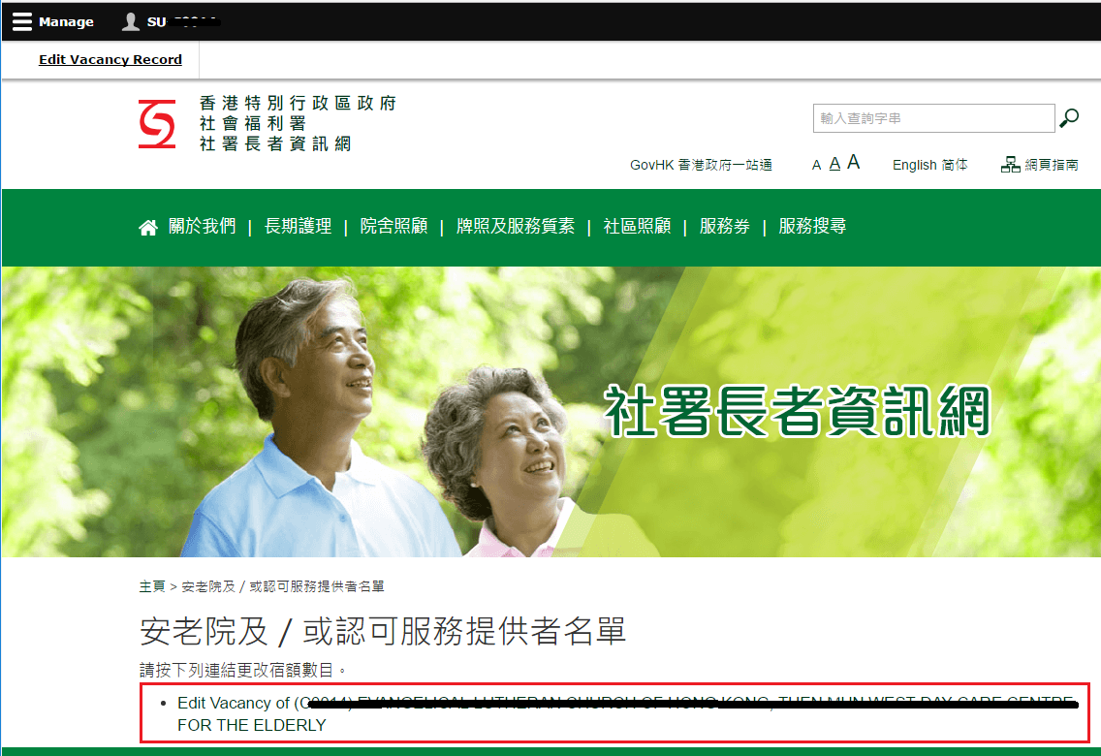

Step 6: Enter the vacancy position(s) for day care places and/or home care places.

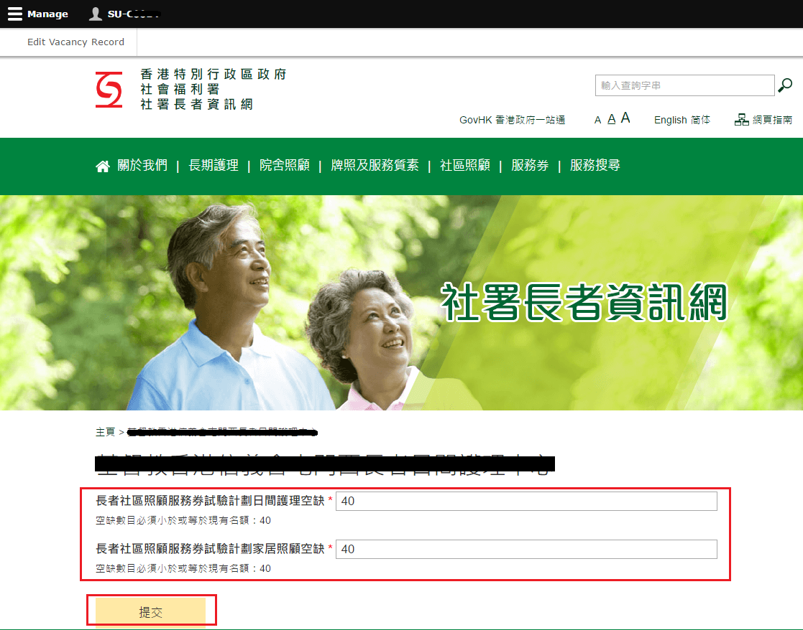

Step 7: Click “Submit” button to update vacancy position(s).

Remarks: Vacancy position(s) for day care places entered shall not exceed the capacity for day care places. Vacancy position(s) for home care places entered shall not exceed the capacity for home care places.

Step 8: To review the published vacancy position(s), click “Search Engine”.

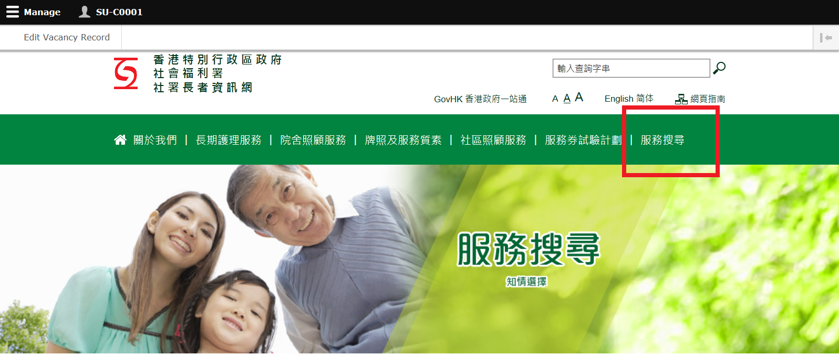

Step 9: Click “Recognised Service Providers of Community Care Service Voucher”. Enter the name of the Recognised Service Provider in the keyword search box and Click “Search”.

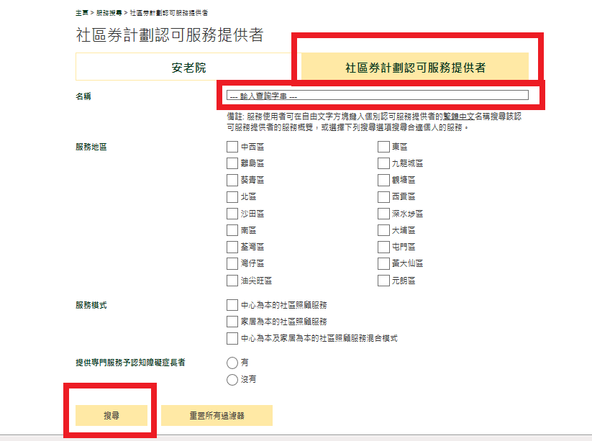
Step 10: Search result(s) would show the Recognised Service Provider requested. Click “Detail” to enter the service profile.

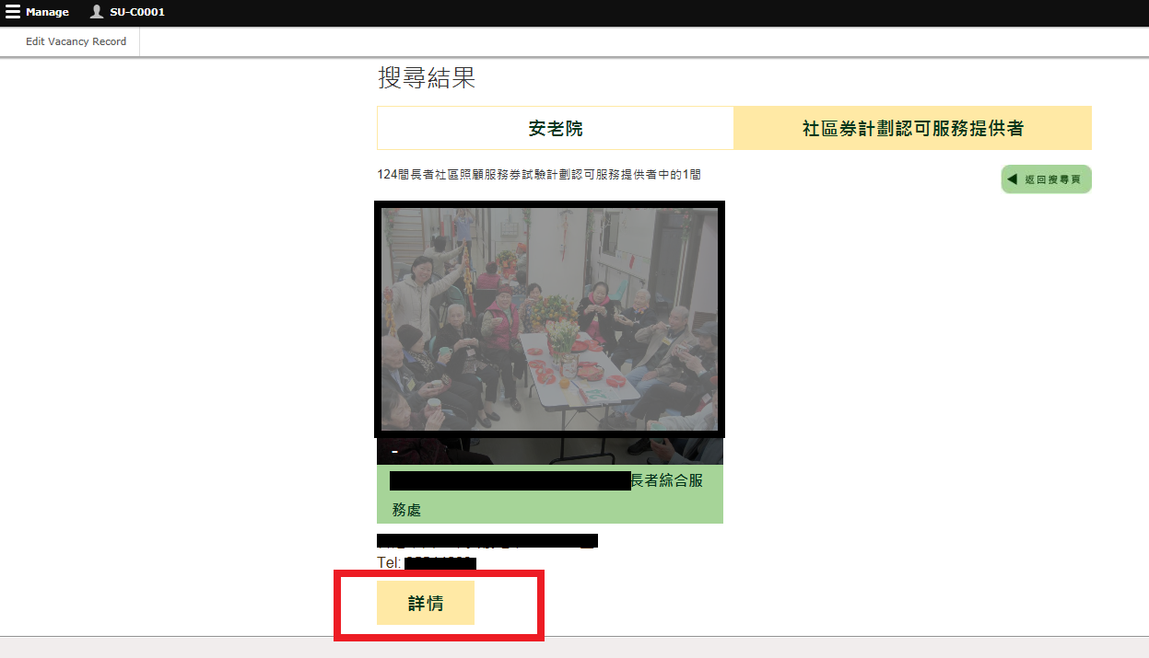

Step 11: Click “Pilot Scheme on Community Care Service Voucher (CCSV) for the Elderly” to view the published vacancy position(s).

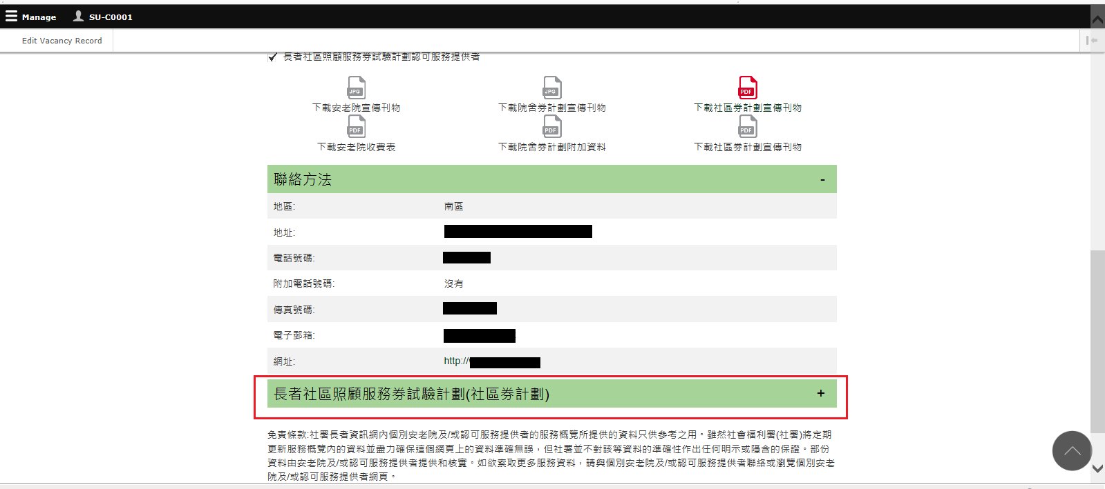

Step 12: Preview and check the display of the published vacancy position(s).

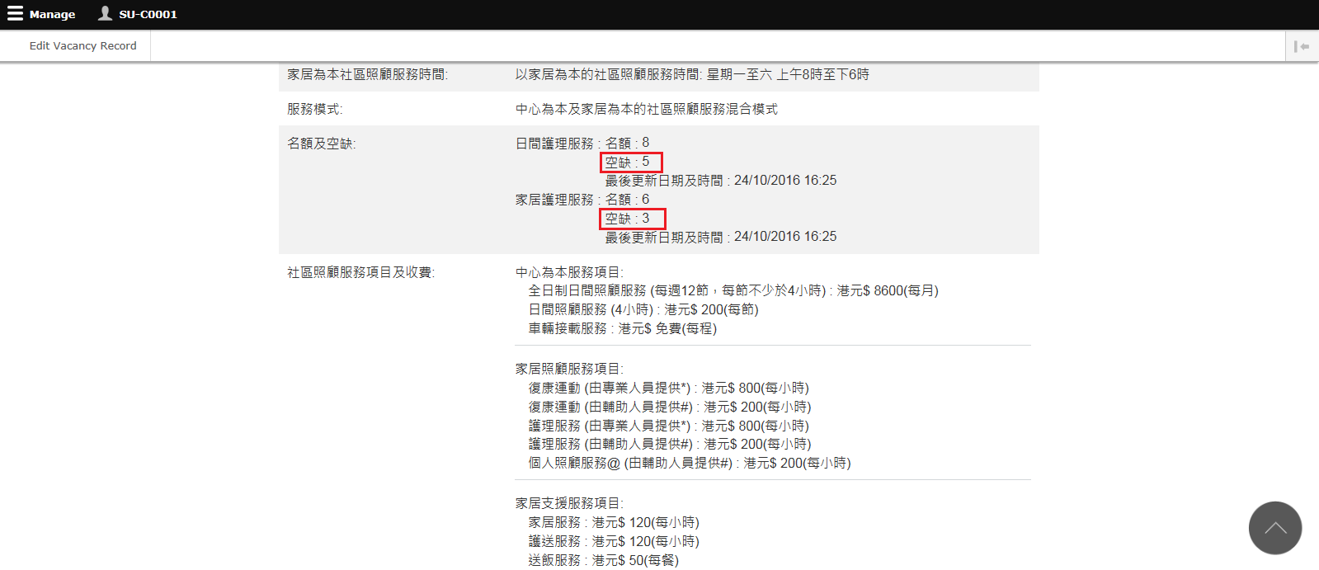

- PROCEDURES OF RESETTING PASSWORD

Step 1: Click Username on the top navigation bar.

Step 2: Click “View profile”.

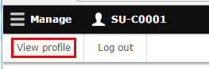

Step 3: Click “Edit”.

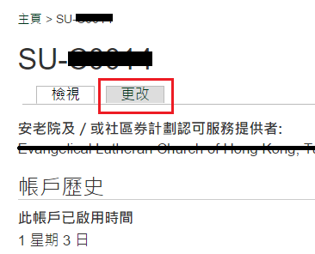

Step 4: Click “Save” to update.
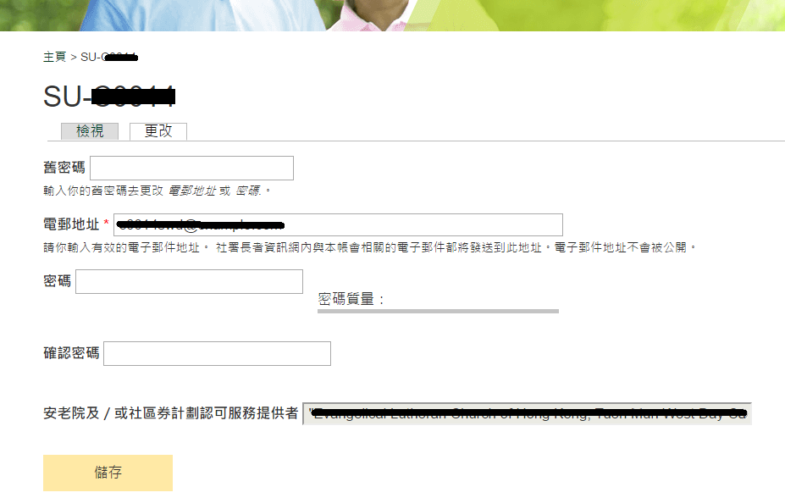

Remarks: Password policies should be adhered. The new password must include enough variation to be secure. Password must contain:
1. at least 10 characters in length;
2. at least 2 uppercase characters (i.e. A-Z);
3. at least 2 lowercase characters (i.e. a-z);
4. at least 2 digits (i.e. 0-9); and
5. at least 2 special (not whitespace or an alphanumeric) characters. (i.e. ? / ; / ! / : / , etc.)

- CONTACT INFORMATION

For enquiries on this user guide, please contact the Community Care Service Voucher Office:

(Attn: Assistant Site Administrator of SWD Elderly Information Website)
Address: Room 1001, 10/F, Wu Chung House, 213 Queen’s Road East, Wan Chai, Hong Kong.
Telephone Number: 3107 3085 / 2116 2749
Fax Number: 2117 1264
Email Address: voucheroffice@swd.gov.hk

